Index Page Screen Short

In This Page I can Simply Create HTML file Which is Contents Assignments Parts link We can simply Click the Button and we can Redirect Assignment Task Solution Page

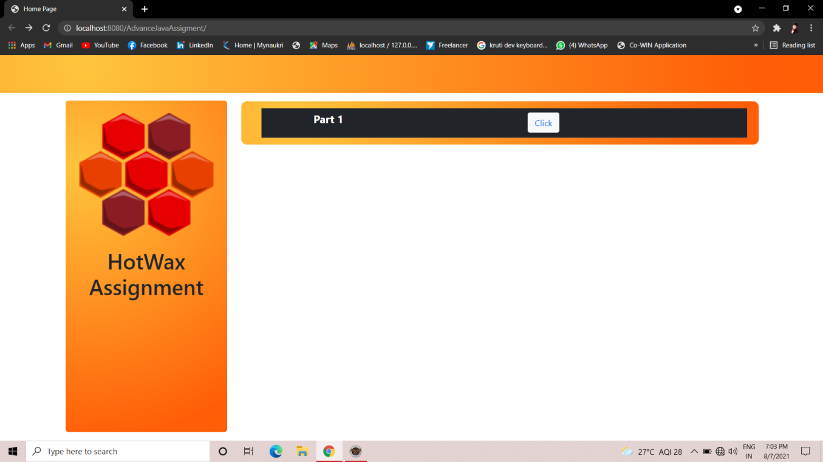

Part 1 Page Screen Short

In This I can complete Advance Java Assignment Part 1 and in This page I can provide all tasks links

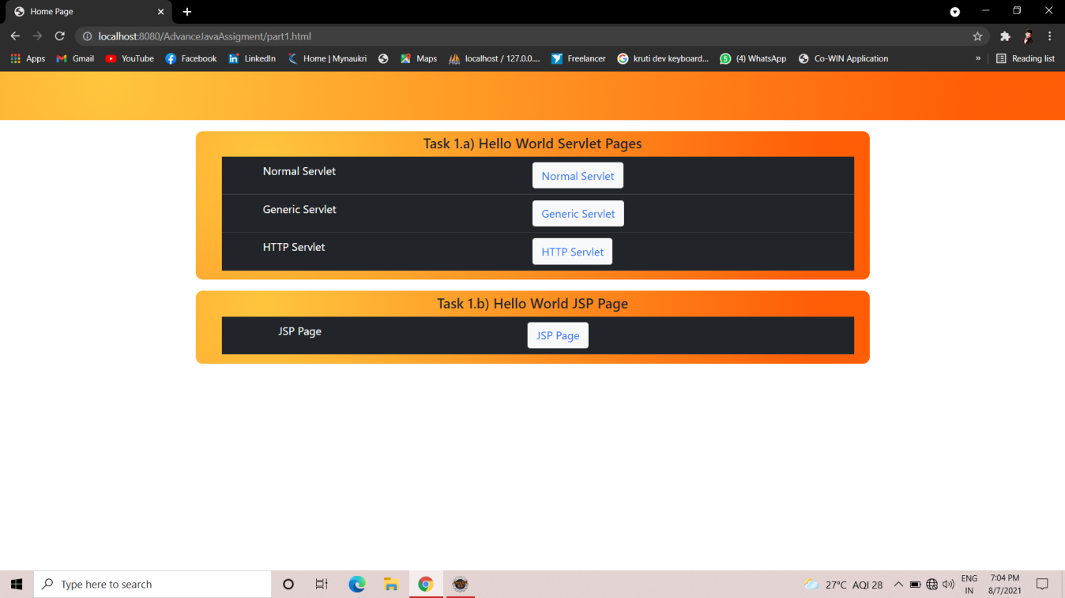

Part 2 Page Screen Short

In This I can complete Advance Java Assignment Part 2 and in This page I can provide all tasks links

